**Web Engineering Exercise 7 – Problem 1**

**s1240234 Yuta Nemoto**

Screenshot: List of products (Show action)

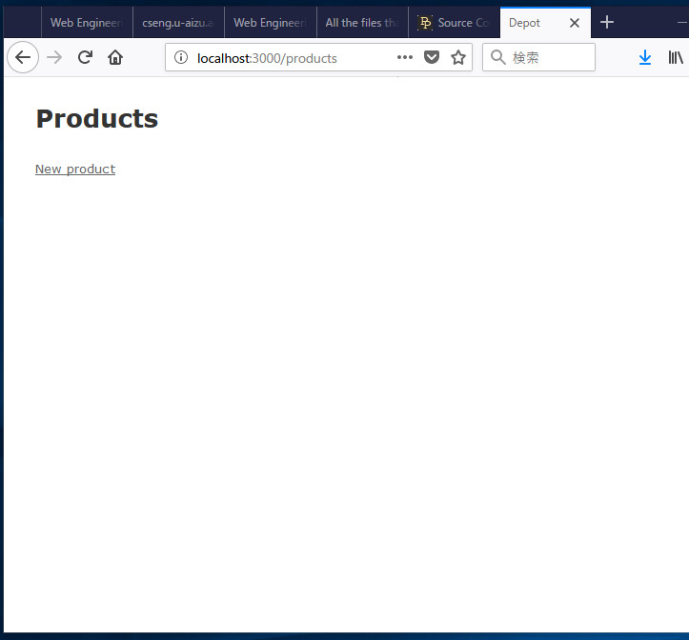

Screenshot: Creating new product

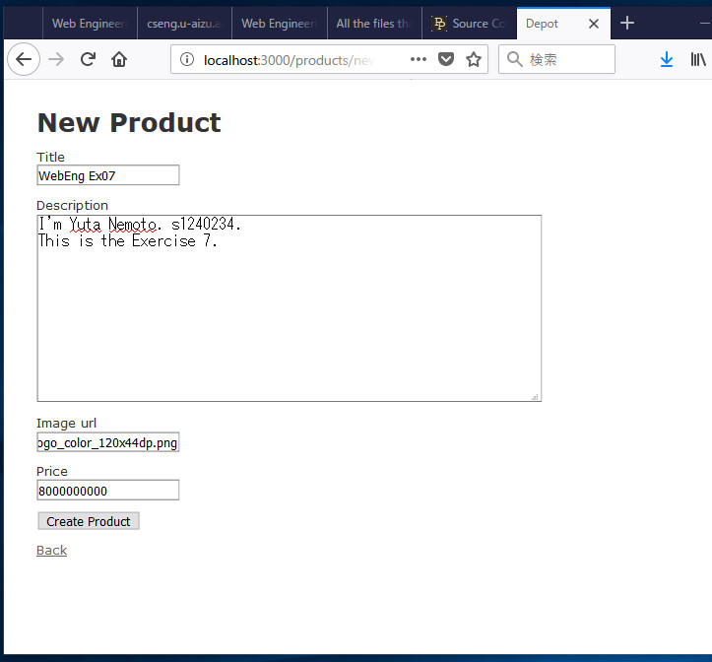

Screenshot: Showing newly created product

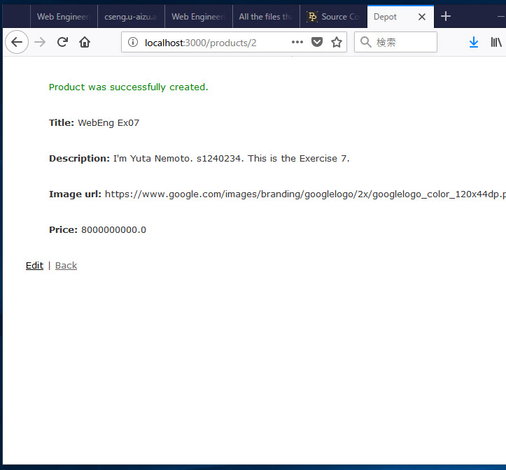

Screenshot: Editing product

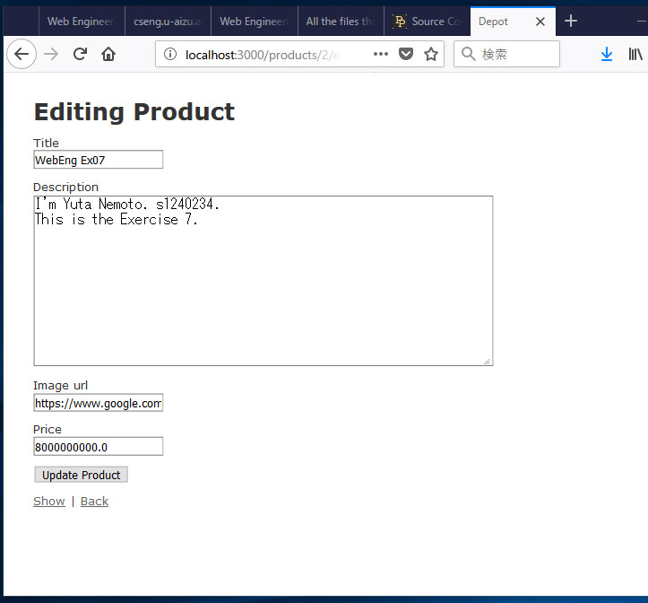

Screenshot: Showing updated product

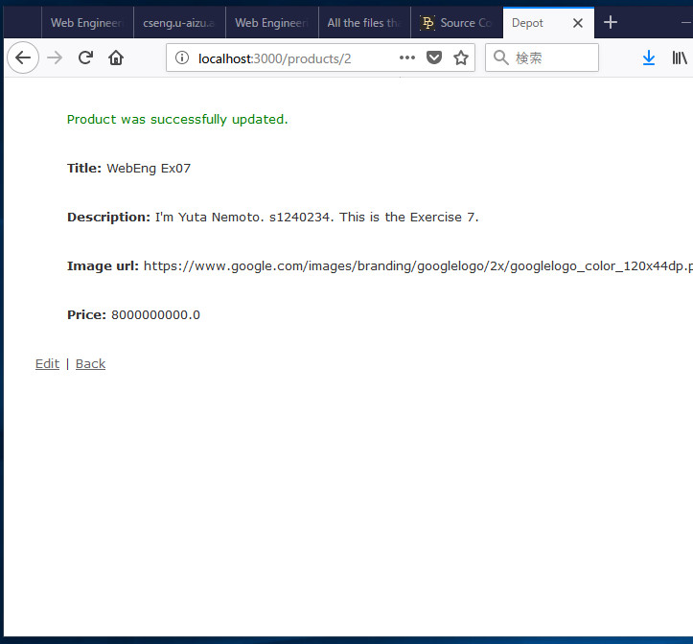

Screenshot: List of product

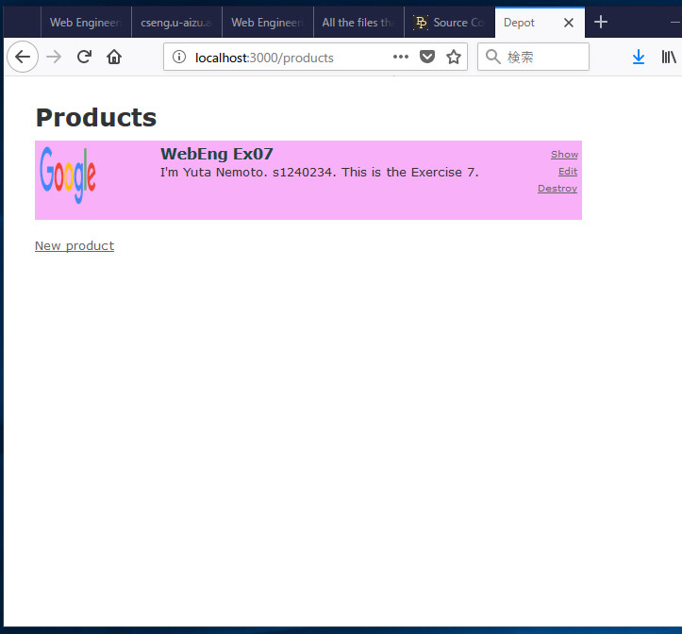

Screenshot: Showing product

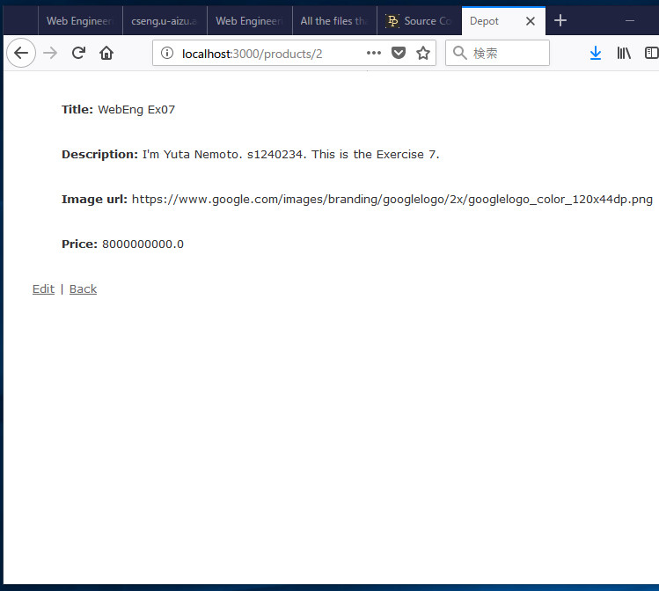

Screenshot: Deleting product

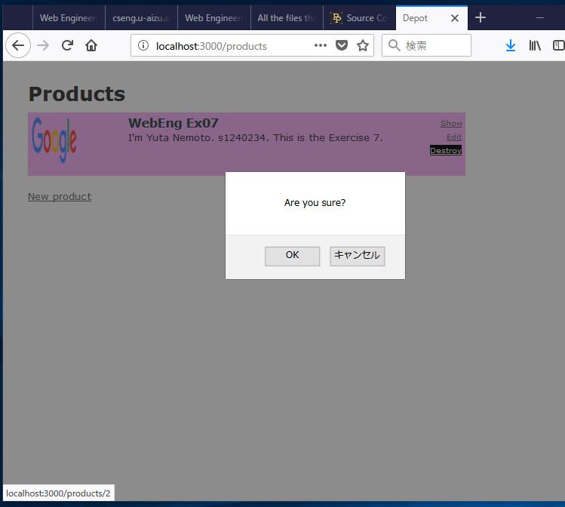

Screenshot: List of product after deleting

